Contents

Sh int trunk 3

Sh etherchannel sum 5

Sh vtp status 7

Sh vlan br 9

sh span mst conf 11

Sh span root 13

Sh run | section span 15

Sh ip int br | exclude unassigned 17

Sh stand br 18

Sh run | section track 19

Sh ip route 20

Sh ip dhcp snooping 23

Sh run | section ip dhcp relay 25

Sh port-security 25

Sh access-list 26

Sh ip int | include line | list 28

Sh run | section vlan access-map 34

Sh run | section vlan filter 34

Sh ip ssh 34

Sh run | section line vty 34

Sh ntp status 35

Sh ntp association 36

Sh vlan private-vlan 37

Sh vlan private-vlan type 37

Ping 200.200.10.5 37

# Sh int trunk

ALS1

ALS2

DLS1

\

DLS2

# Sh etherchannel sum

ALS1

ALS2

DLS1

DLS2

# Sh vtp status

DLS1

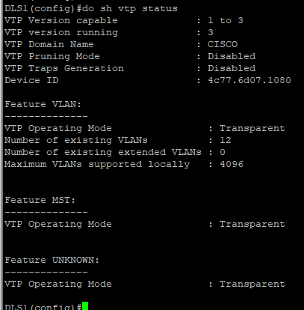

DLS2

ALS1

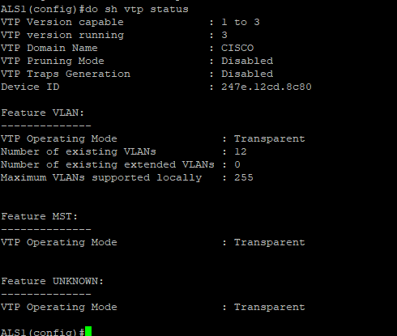

ALS2

# Sh vlan br

ALS1

ALS2

DLS1

DLS2

# sh span mst conf

ALS1  
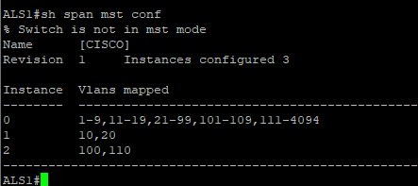

ALS2  
  
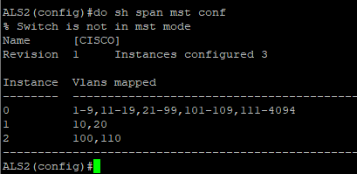

DLS1

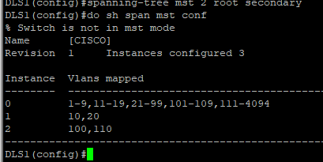

DLS2

# Sh span root

ALS1

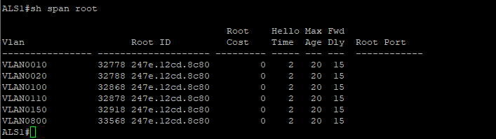

ALS2

DLS1

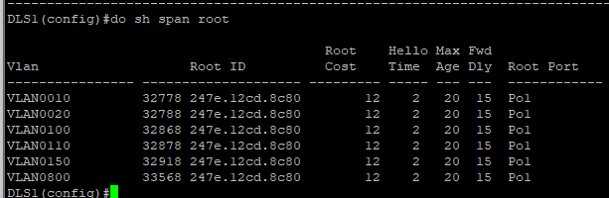

DLS2

# Sh run | section span

ALS1

ALS2

DLS1

DLS2

# Sh ip int br | exclude unassigned

ALS1

ALS2

DLS1

DLS2

# Sh stand br

DLS2

DLS1

# Sh run | section track

DLS1

DLS2

# Sh ip route

DLS2

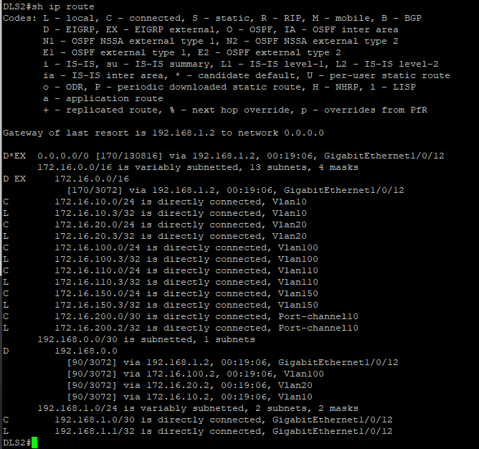

DLS1

GatewayR1

# Sh ip dhcp snooping

ALS2

ALS1

# Sh run | section ip dhcp relay

DLS2

DLS1

# Sh port-security

ALS2

ALS1

# Sh access-list

ALS1

DLS2

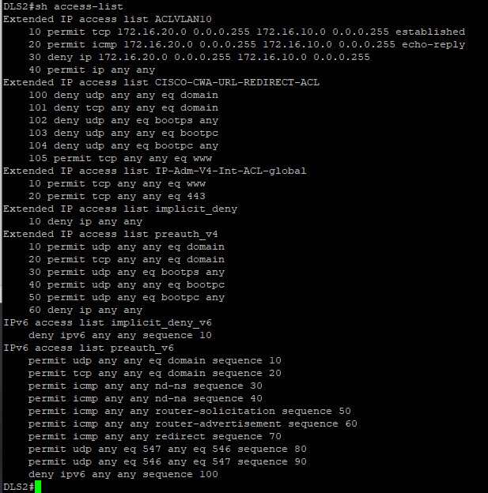

DLS1

# Sh ip int | include line | list

DLS1

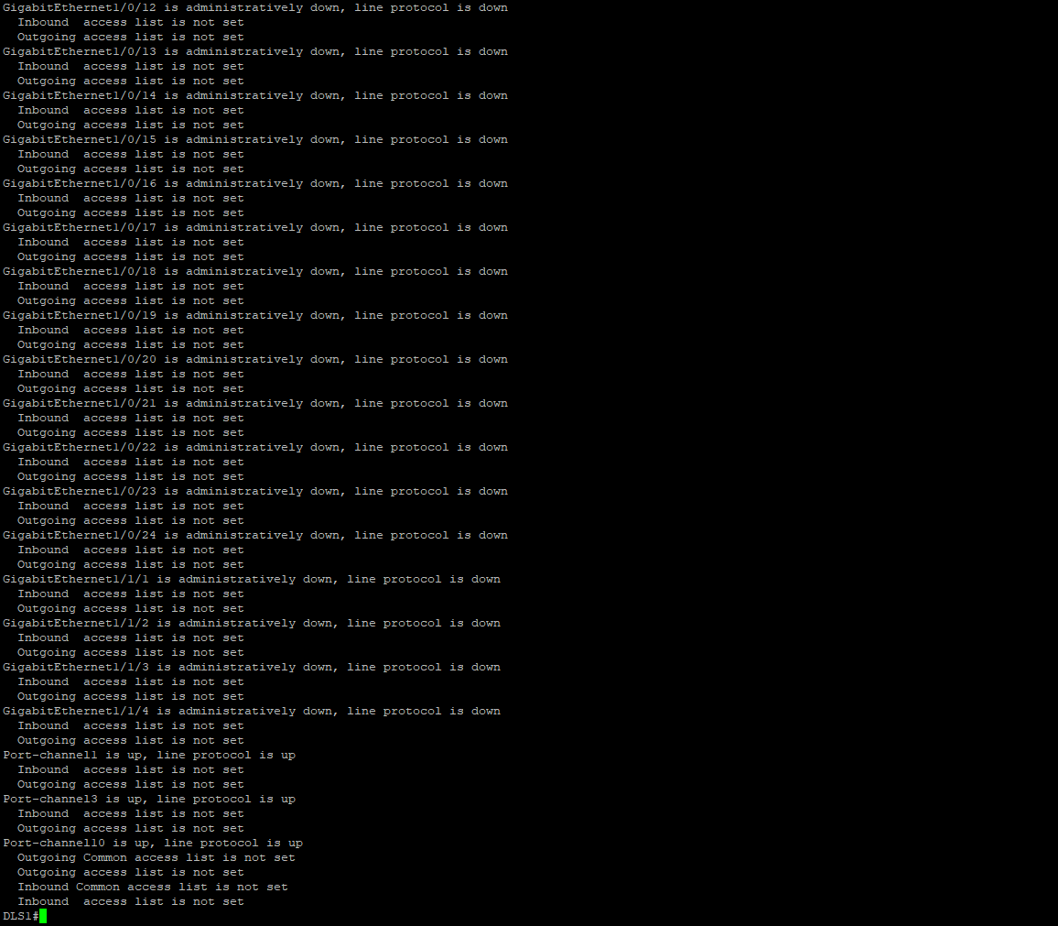

ASL1

DLS2

# Sh run | section vlan access-map

ALS1

# Sh run | section vlan filter

# Sh ip ssh

# Sh run | section line vty

# Sh ntp status

ALS1

ALS2

DLS1

DLS2

Sh ntp association  
ALS1

ALS2

DLS1

DLS2

# Sh vlan private-vlan

DLS2

# Sh vlan private-vlan type

DLS2

# Ping 200.200.10.5

ALS1

ALS2

